www.norcalflightcenter.com
916-794-1359
1420 Flightline Drive
Lincoln, CA 95648
customerservice@norcalflightcenter.com

AVIATION REMINDERS AND ACRONYMS

Risk Elements
PAVE
P - Pilot
A - Aircraft
V - Environment
E – External Pressures

Flight Fitness
IMSAFE
I - Illness—Do I have any symptoms?
M - Medication—Have I been taking prescription or over-the-counter drugs?
S - Stress—Am I under psychological pressure from the job? Worried about thing?
A – Alcohol— Sec. 91.17 — Alcohol or drugs. (8 hours bottle to throttle; Not over 0.04 Blood)
F - Fatigue—Am I tired and not adequately rested?
E - Eating—Am I adequately nourished?

Five Hazardous Attitudes
I’M AIR

I - Impulsivity - "Not so fast. Think first."
M - Macho - "Taking chances is foolish."
A - Anti-Authority - "Follow the Rules."
I - Invulnerability - "It could happen to me."
R - Resignation - "I'm not helpless. I can make a difference."

61.3 Documents in Possession
PPME

P - Pilot certificate
P - Photo identification
M - Medical certificate.
E - Endorsements

91.103 – Preflight action.
NWKRAFT
N – Notams/TFR’s
W - Weather
K - Known ATC Delays
R - Runway Lengths
A - Alternatives
F – Fuel Requirements 91.151 (enough fuel to fly to the first point of intended landing and, assuming normal cruising speed(1) During the day, to fly after that for at least 30 minutes; or (2) At night, to fly after that for at least 45 minutes.)
T – Take-off Data

91.409 - Required Aircraft Inspections
AVIATES

A – Annual and Airworthiness Directives (AD’s)
V – VOR Check (30 days) (IFR Only)
I – Inspections - 100 hour (For Hire Only)
A – Altimeter (24 Calendar Months) (IFR Only)
T – Transponder (24 Calendar Months)
E – ELT (12 Calendar Months) The batteries must be replaced or recharged: When the transmitter has been in use for more than 1 cumulative hour; or when 50 percent of their useful life
S – Static System (24 Calendar Months) (IFR Only)

91.203+91.9+43.5 - Required Aircraft Documents for Airworthiness
ARROW
A – Airworthiness Certificate
R – Registration
R – Radio Certificate (required for international flights)
O – Operators Manual (Pilots operating handbook doesn’t count)
W – Weight and Balance (current and specific to your airplane)

91.205(b) - VFR Day Equipment Requirements
A TOMATO FLAMES

A – airspeed indicator
T – tachometer (for each engine)
O – oil pressure gauge (for each engine using a pressure system)
M – manifold pressure gauge (only for complex engine)
A – altimeter
T – temperature gauge (for each liquid cooled engine)
O – oil temperature gauge (for each air cooled engine)
F – fuel gauge
L – landing gear position indicator (for retractable gear airplane)
A – anti collision lights (for aircraft certified after March 11th 1996)
M – magnetic compass
E – ELT
S – safety belts

91.205(c) VFR Night Equipment Requirements
FLAPS
F – fuses (one complete spare set)
L – landing light (only if you are flying for hire)
A – anti collision lights*
P – position lights
S – source of electricity (alternator, generator)

Lost Procedures
5 C’s
Climb
Circle
Conserve
Confess
Comply

Engine Out
ABCD

A - Airspeed – Best Glide Speed
B - Best Landing Spot
C - Checklist/Cockpit Scan
D - Declare Emergency (121.5, 7700)

Emergency
AVN

A - Aviate
N - Navigate
C – Communicate

Initial Call to ATC
IPAD

I - Identification - Who are you?
P – Position - Where are you?
A – Altitude
D – Intentions

4 W’s

Who are you calling
Who you are
Where you are
What you want to do

Prelanding Check
GUMPPSSS

G - Gas (fullest tank)
U- Undercarriage (gear down and locked)
M - Mixture (full rich)
P - Propeller (high RPM)
P - Pumps
S - Servo (Autopilot)
S - Switches (Landing Light, Fuel Pump)
S - Seatbelt

Airspace
ABCDEG
ABCDE = controlled airspace
G – Uncontrolled

A – Above – 18000+ = IFR
B – Big Tower
C – City Tower
D – Dinky Tower
E - Everywhere
G – Ground (up to 700 at airport with IFR approach, up to 1200 at airport without)

Airspace Requirements

Cloud requirements
Visibility
Pilot Requirements
Equipment Needed

91.155 Flight visibility and cloud clearance requirements
3152, 5111, 3 COC, 1 COC

3-COC = B
3-152 = CDE+G Night
5-111 = E+G above 10k (1000 above, 1000 below, 1 mile horizontal)
1-COC = G

Cloud coverage

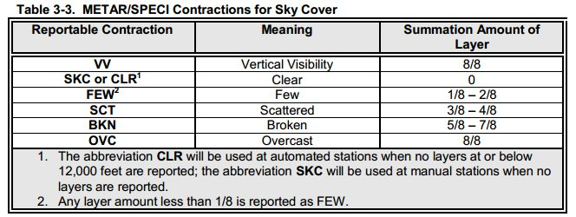

Cloud Levels
METAR and TAF = AGL
Area Forecast/PIREPS = MSL

VOR’s

- Draw compass and draw desired radial + reciprocal radial
- Determine position by the “To” and “From” flag
- Determine needle offset –
  - VOR – needle is deflected to correct side if aircraft is heading “TO” the heading selected in the VOR receiver
  - HSI – No Reverse Sensing – Needle is always deflected to correct side
- Aircraft Heading is Irrelevant

True vs Magnetic Headings
True if you read it. Magnetic if hear it.

Metar Format
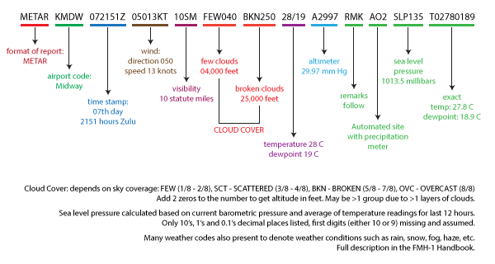

91.159 ALTITUDES (based on Mag course = (True Course +/- Mag Var)
“E comes before O”

0-179° Magnetic = Odd Altitude + 500ft IFR = ODD ALTITUDE
180-359° Magnetic = Even Altitude + 500ft IFR = EVEN ALTITUDE

Types of Altitude
“True IPAD”

T - True
I - Indicated
P - Pressure
A - Absolute
D – Density

PITOT TUBE AND STATIC TUBE BLOCKAGES
PUD
P - Pitot tube blocked
U – Under (Airspeed decreases with altitude loss- turns into an altimeter)
D - Descent

SUC
S – Static Port blocked (both)
U – Under (Airspeed decreases with altitude gain – turns into an altimeter)
C – Climb

Flight Planning Course

True Heading/Course
+/- Mag Variation (East is Least, West is Best)(difference between magnetic and true north)
+/- Mag Deviation (airplane’s effect on compass)
+/- WCA Wind Correction Angle (East is Least, West is Best)
= Compass Heading

Magnetic Compass Errors

ANDS - Accelerate North/Decelerate South
UNOS – Undershoot North/Overshoot South
Turns from 90/180 if made smooth will initially be accurate

AIRMETS
Sierra – IFR Visibility or Mountain Obscuration
Tango - Turbulence
Zulu - Icing
91.211 Supplemental Oxygen Requirements
12,500-14000 = Crew if over 30 mins
14000+ = Crew at all times
15000+ = Everyone

Pacific Time = Zulu – 8 Daylight Savings Time = Zulu – 7
Night
  - Logging
End of evening civil twilight to beginning of morning civil twilight

61.57 Recency
1 hour after sunset to 1 hour before sunrise
Prior 90 days, 3 takeoffs/ 3 landings to full stop

91.209+ 91.205(c) Lights
Sunset to Sunrise
Position Lights
Anti-collision Lights
Landing Lights (if for hire)

Maneuvering Speed – Va increases/decreases by 2 knots for every 100 lb increase/decrease in weight

INSTRUMENT FLIGHT
91.205(d) IFR Equipment Required
GRABCARD

G - Generator/Alternator
R - Radios (appropriate for flight)
A - Altimeter (sensitive/adjustable)
B - Ball
C - Clock (second hand sweep or digital)
A - Attitude indicator
R - Rate of turn
D- Directional gyro

IFR Approach Briefing

MARTHIA

M - Missed Approach
A - Altitudes
R - Radios
T - Times
H - Heading
I - Identify
A - Alternate

Instrument Clearance
CRAFT

C - Cleared to
R - Route
A - Altitude
F - Frequency (departure)
T – Transponder

91.171 – IFR VOR Checks
Dog Poop, Bear Shit
D- Date
P - Place
B - Bearing error
S - Signature

91.171 VOR Tests
Ground = 4
Airborne = 6
- Exception Dual VOR = 4

Lost Communication

Fly highest ALTITUDE:
MEA

M- Minimum IFR Alt (could be MEA, OROCA, etc)
E- Expected
A – Assigned

Fly the last ROUTE:
CAVE-F

C - Cleared
A - Assigned (Your last assigned heading)
V - Vectored (If nothing is assigned fly your last vector)
E - Expected (If no vector fly what was expected in your clearance)
F - Filed (Finally fly what you filed)

Illusions In Flight
ICE FLAGGS
I - Inversion (Climb to straight and level = Tumbling backwards feeling)
C - Coriolis (Head movements in prolonged turns)
E - Elevator (Updraft/Downdraft causes a pilot to pitch up or down)
F - False Horizons (Sloping clouds, terrain, etc)
L - Leans (Banking illusion that occurs by relying on physical sensations rather than instrumentation)
A - Autokinesis (Stationary lights appear to move)
G - raveyard Spiral (Constant rate turn downwards)
G - Graveyard Spin (Pilot recovers from spin but senses they are in a new spin, so re-enter that spin)
S - Somatogravic (Caused by rapid acceleration or deceleration that results in a pitch up or down)

Mandatory Reports To ATC

Required Reporting Points in Radar Contact:
HUMANSS

[H]old (entering, leaving)
[U]nable (to climb or decend at 500 ft/min)
[M]issed Approach
[A]ltitude change (ifr or vfr on top)
[N]avigational Capability Lost
[S]peed change of 5% or 10 knots, whichever is greater
[S]afety of flight (anything)

Required Reporting Points Non-Radar Contact:
CTUF (Like CTAF)

C – Compulsory Reporting Points (Filled in NAVAID OR WAYPOINT)
T - Time estimate change of more than 3 minutes
U - Unplanned Weather
F - Final Approach Fix

HINT: Target Bank Angle in Degrees for amount of degrees you wish to turn. If minor corrections, just use rudder.
KEEP THE WINGS LEVEL, AND AVOID TURNS AS MUCH AS POSSIBLE
USE RUDDER TO MINIMIZE BANKS, AND USE Aileron to center ball
DON’T BANK MORE THAN 30 degrees ever!
Don’t bank more than standard rate turns.

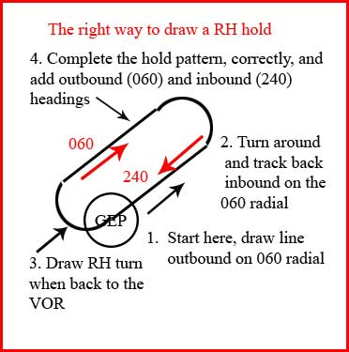

PG. 573 in Instrument Flying Book

How to draw a hold at a fix other than VOR:
1. Draw radial outbound.
2. Hit DME fix or waypoint, and make right or left turn.

How to draw a hold that originates at VOR:
1. Draw radial outbound,
2. Turnaround and follow radial back into the VOR/FIX
3. Draw right or left turn when crossing fix.

When do I file an alternate?

If weather at my initial intended destination is not: 1-2-3:
- +/- 1 hour of arrival time
- 2000 ft ceiling
- 3 mile visibility

POWER PITCH TRIM

Initiate Climb
Initiate Descent

PITCH POWER TRIM

Level Off After Climb
Level off after Descent

TWO METHODS OF SCANNING THE INSTRUMENTS

In the real world, you will develop your own flow, but going to the AI every couple of seconds is mandatory.

Control and Performance Method (Some people like for Transitions)
- Control
Attitude(AI) + Power(RPM/MP)
Put the plane where you want it go. Pitch + Power = Performance

- Performance
Altimeter, ASI, VSI, HI, TI
Pitch plus Power = Performance

Primary and Supporting Method (Some people prefer in Straight and Level)

Flight Regime | Primary  Pitch | Supporting  Pitch | Primary  Bank | Supporting  Bank
Straight-And-Level | ALT | AI/VSI | DG | AI/TC
Constant Airspeed Climb/Descent | ASI | AI/VSI | DG | AI/TC
Constant Rate Climb/Descent | VSI | AI | DG | AI/TC
Standard Rate Turn | ALT | AI/VSI | TC | AI

